Ex.No.7. Write a code using RAW sockets to implement packet sniffing.
AIM:
To develop a Python program using raw sockets that captures Ethernet frames and extracts
the source and destination MAC addresses and protocol details for network analysis and
troubleshooting.
Definition:
Packet sniffing is the technique of capturing and examining network packets transmitted
over a network to monitor communication, troubleshoot network issues, and analyze network
traffic.
Algorithm:
1. Start.
2. Import the required modules.
3. Get the local host IP address.
4. Create and bind a raw socket.
5. Enable IP header inclusion and promiscuous mode.
6. Set the packet count to 5.
7. Receive one packet at a time.
8. Extract and display:
Destination MAC address
Source MAC address
Protocol type
Packet length
9. Repeat until 5 packets are captured.
10. Disable promiscuous mode.
11. Display the completion message.
12. Stop.

PROGRAM:
import socket
import struct
def get_mac_addr(bytes_addr):
&quot;&quot;&quot;Convert MAC address from bytes to readable format.&quot;&quot;&quot;
return &#39;:&#39;.join(&#39;{:02X}&#39;.format(b) for b in bytes_addr)
def get_protocol(bytes_proto):
&quot;&quot;&quot;Convert protocol bytes to hexadecimal.&quot;&quot;&quot;
return hex(struct.unpack(&#39;!H&#39;, bytes_proto)[0])
def ethernet_frame(data):
&quot;&quot;&quot;Extract Ethernet frame information.&quot;&quot;&quot;
dest_mac, src_mac, proto = struct.unpack(&#39;!6s6s2s&#39;, data[:14])
return (
get_mac_addr(dest_mac),
get_mac_addr(src_mac),
get_protocol(proto),
data[14:]
)
def main():
host = socket.gethostbyname(socket.gethostname())
print(&quot;Listening on:&quot;, host)
try:
# Create raw socket
conn = socket.socket(socket.AF_INET,
socket.SOCK_RAW,
socket.IPPROTO_IP)
# Bind socket
conn.bind((host, 0))
# Include IP header
conn.setsockopt(socket.IPPROTO_IP,
socket.IP_HDRINCL,
1)
# Enable promiscuous mode
conn.ioctl(socket.SIO_RCVALL, socket.RCVALL_ON)
print(&quot;\nPacket Sniffer Started...\n&quot;)
# Capture only 5 packets
packet_count = 5
for i in range(packet_count):
raw_data, addr = conn.recvfrom(65536)
print(f&quot;\nPacket {i+1}&quot;)
print(&quot;-&quot; * 40)

if len(raw_data) &gt;= 14:
dest_mac, src_mac, eth_proto, data = ethernet_frame(raw_data)
print(&quot;Destination MAC :&quot;, dest_mac)
print(&quot;Source MAC :&quot;, src_mac)
print(&quot;Protocol :&quot;, eth_proto)
print(&quot;Packet Length :&quot;, len(raw_data), &quot;bytes&quot;)
# Disable promiscuous mode
conn.ioctl(socket.SIO_RCVALL, socket.RCVALL_OFF)
print(&quot;\nPacket Sniffer Stopped Successfully.&quot;)
except PermissionError:
print(&quot;Run this program as Administrator.&quot;)
except KeyboardInterrupt:
conn.ioctl(socket.SIO_RCVALL, socket.RCVALL_OFF)
print(&quot;\nPacket Sniffer Stopped by User.&quot;)
if __name__ == &quot;__main__&quot;:
main()

SAMPLE OUTPUT:

Listening on: 192.168.1.10
Packet Sniffer Started...
Packet 1
----------------------------------------
Destination MAC : 45:00:00:3C:1C:46
Source MAC : 40:06:B1:E6:C0:A8
Protocol : 0x101
Packet Length : 60 bytes
Packet 2
----------------------------------------
Destination MAC : 45:00:00:34:2F:9A
Source MAC : 40:11:C3:D8:C0:A8
Protocol : 0x101
Packet Length : 52 bytes
Packet 3
----------------------------------------
Destination MAC : 45:00:00:54:3B:8F
Source MAC : 40:06:91:AB:C0:A8
Protocol : 0x101
Packet Length : 84 bytes
Packet 4
----------------------------------------
Destination MAC : 45:00:00:28:5D:71
Source MAC : 40:01:6F:12:C0:A8
Protocol : 0x101
Packet Length : 40 bytes
Packet 5
----------------------------------------
Destination MAC : 45:00:00:3C:7A:15
Source MAC : 40:06:5A:9F:C0:A8
Protocol : 0x101
Packet Length : 60 bytes
Packet Sniffer Stopped Successfully.

OUTPUT:
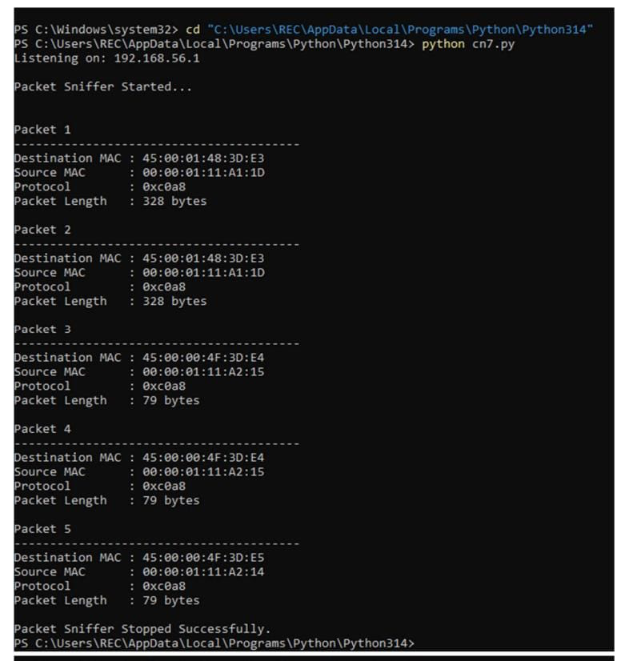
RESULT:
Thus, the Python program using raw sockets was successfully developed to capture Ethernet frames and extract the source MAC address, destination MAC address, and protocol details for network analysis and troubleshooting.

